IFTS 14 – ROBOTICA – INGLES TECNICO II

TASK 3

1. READING COMPREHENSION:
2. The text below was taken from “The Art of Electronics” by Horowitz and Hill. What’s the title of this chapter?

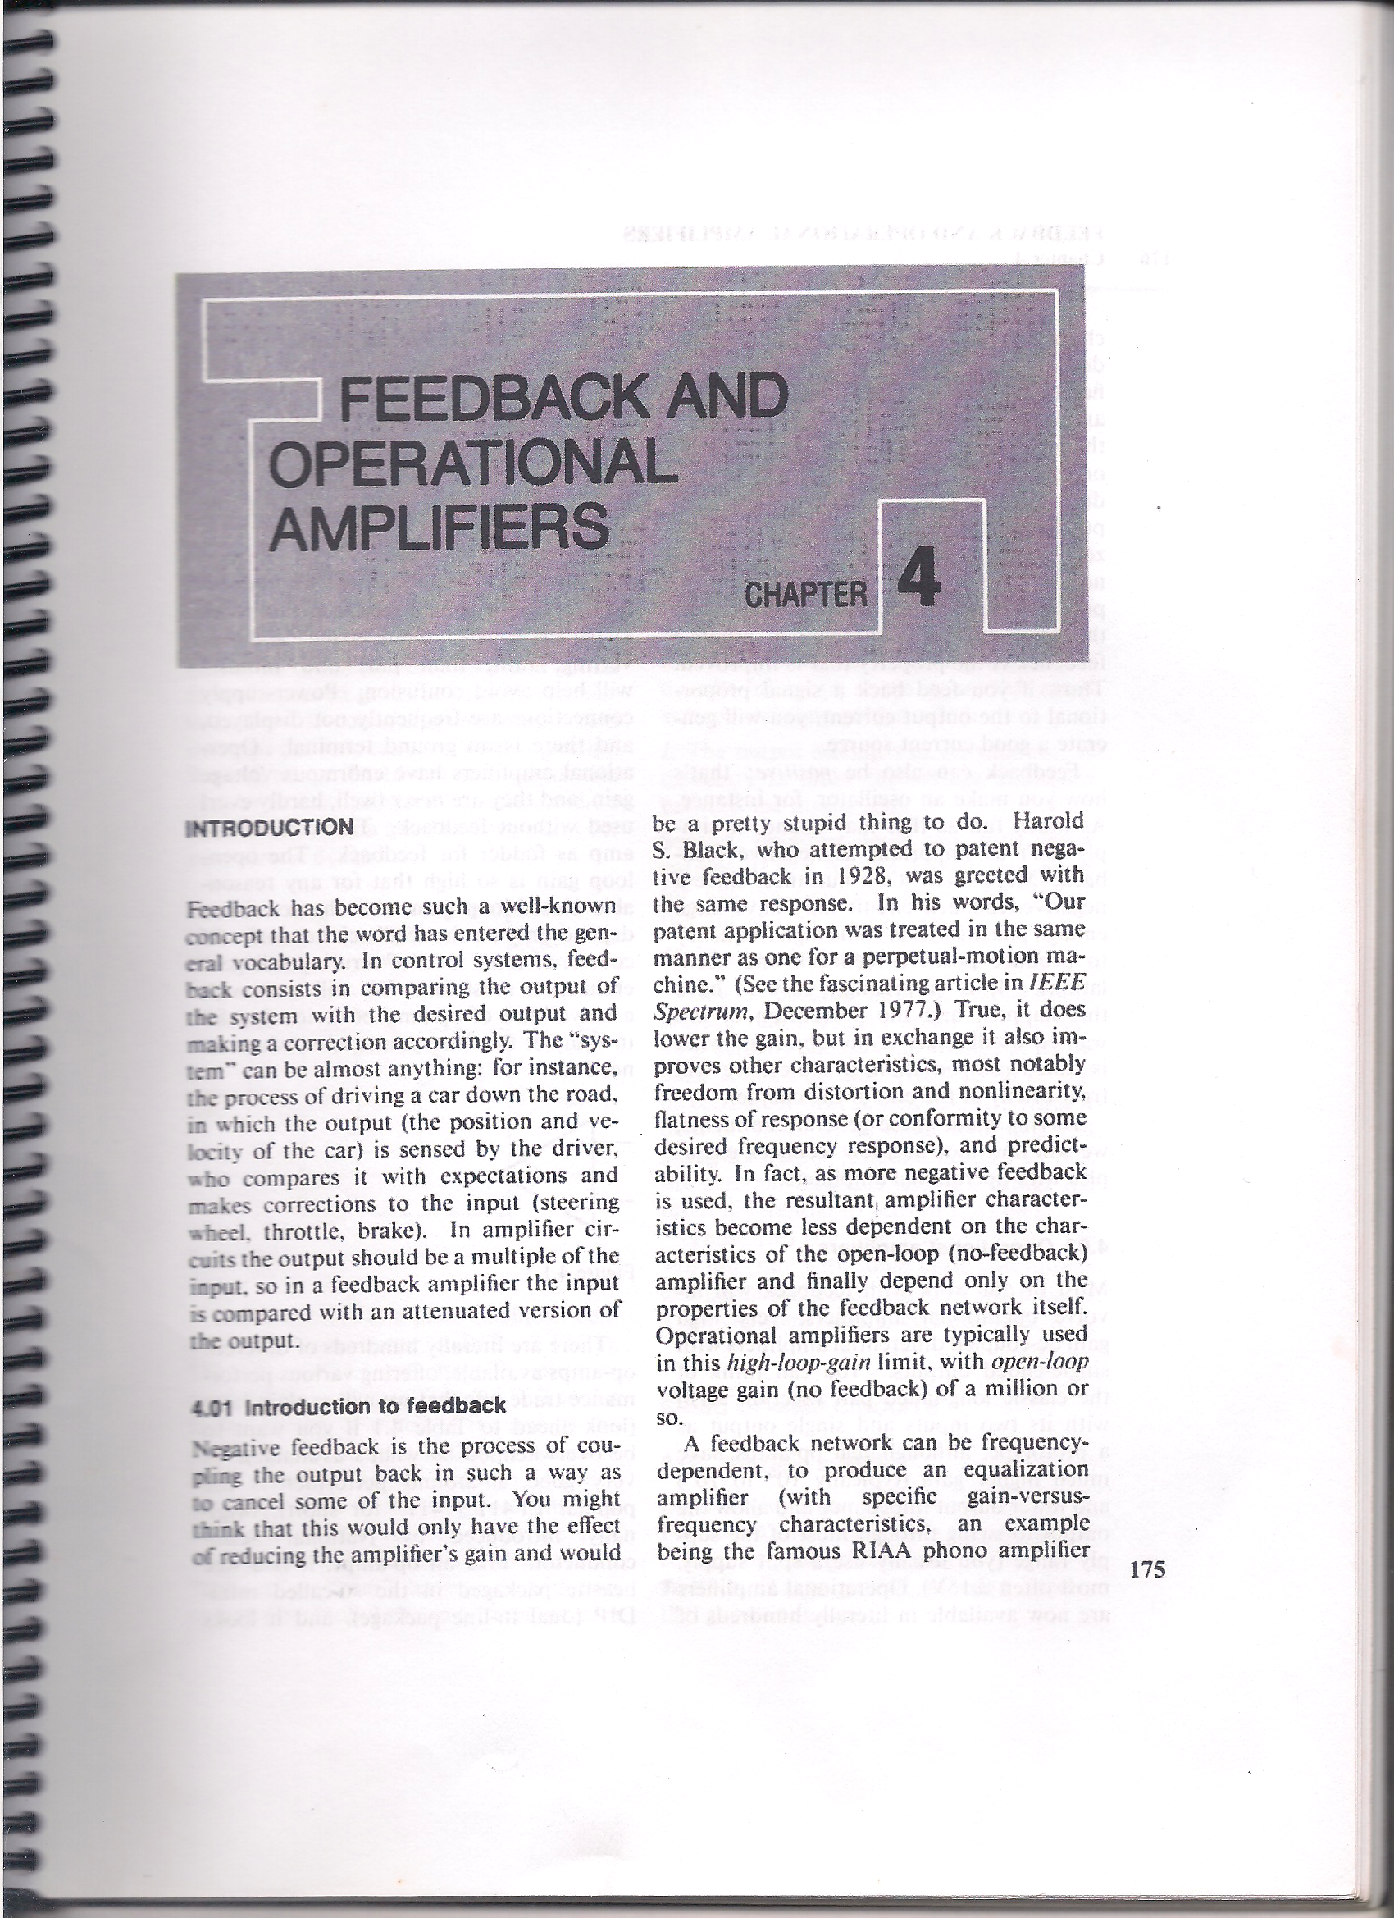

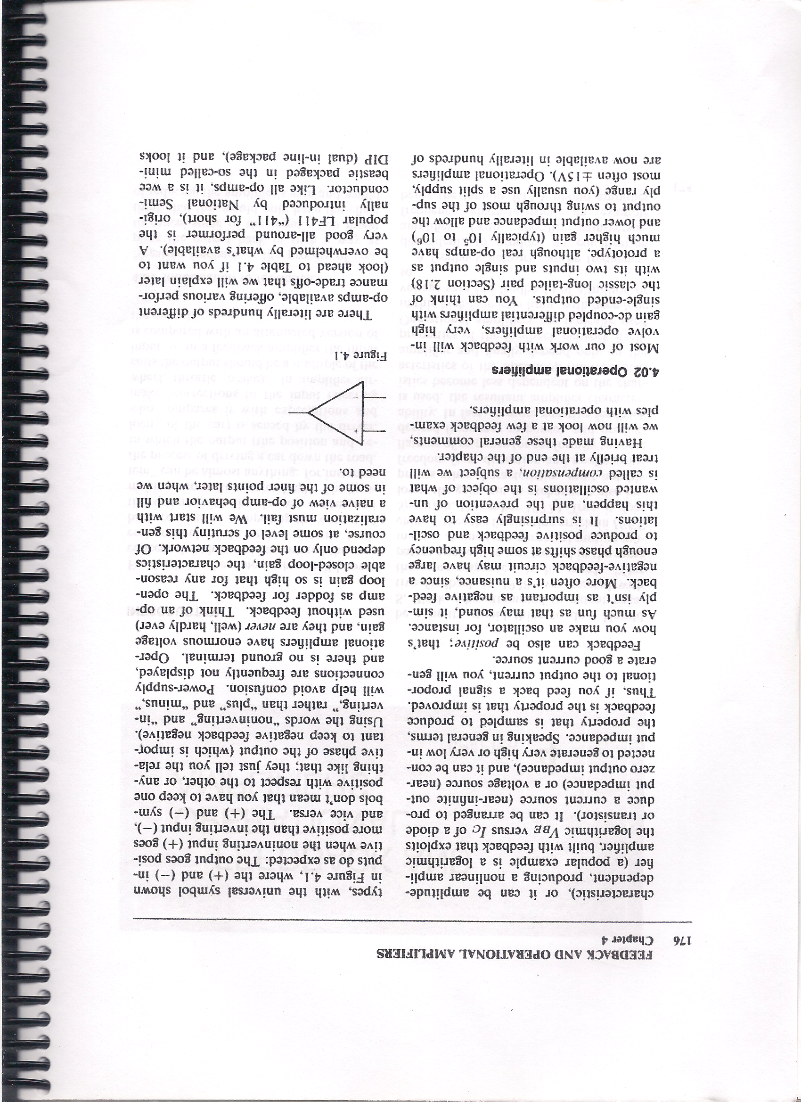

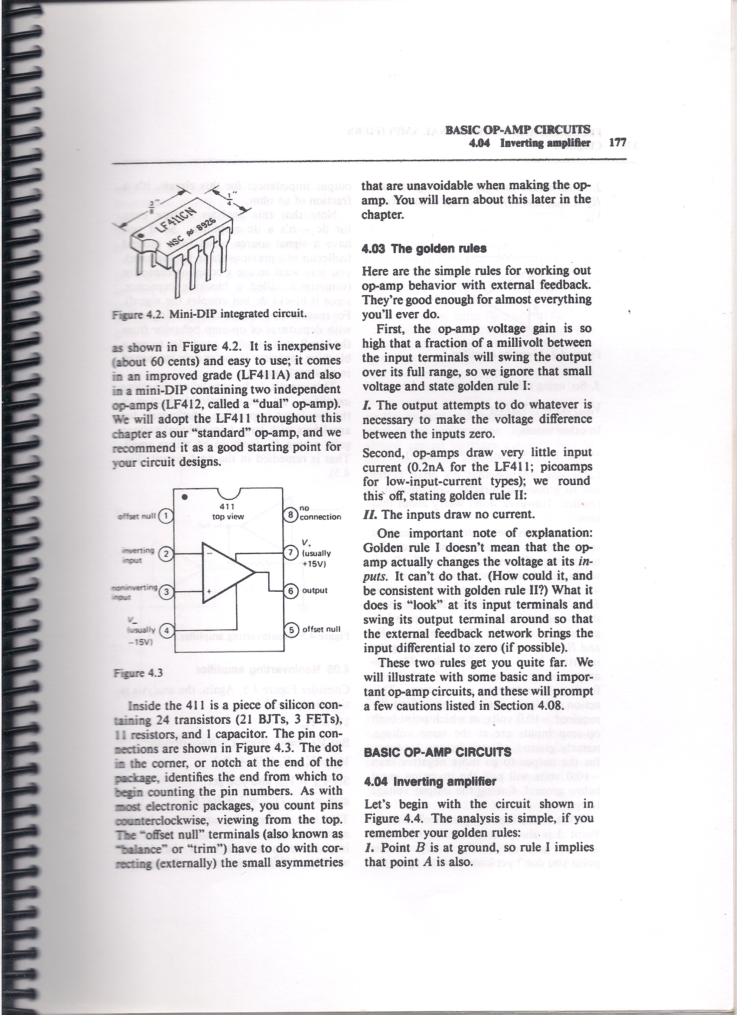

1. Scan the text to answer the following questions in Spanish:
2. What is feedback in control systems?
3. What types of feedback are there?
4. What are operational amplifiers?
5. Explain the first golden rule.
6. Explain the second golden rule.
7. Explain the third golden rule.
8. What do the symbols + and – mean in the op am input?
9. What type of source of power is normally used?
10. What can easily happen with positive feedback?
11. **LANGUAGE FOCUS**

Look at the following IF sentences taken from the text:

1. If you feed back a signal proportional to the output current, you will generate a good current source.
2. Look ahead to Table 4.1 if you want to be overwhelmed.

How many clauses (S+V) are there in each sentence?

What is the verb tense sequence in each one?

The conditional sentences in these examples talk about a real situation and its result (Zero or First Type)

Refer to Guia de la Traduccion section 27.3 - Conditional Sentences.

Let’s turn example 1) from the text (conditional type one) into conditional sentences of the other types (Second and Third) and analize the difference in meaning.